Name
Course title
Date
Question 1  (a). f(x) = -3x²+11x-5  Then, f (-2) = -3(-2)²+11(-2)-5  =-3x4-22-5  =-12-22-5  f (-2)=-39  (b) f (x)=1  -3x²+11x-5=1  3x²-11x+5=-1  3x²-11x=6=0  3x²-9x-2x+6=0  3x(x-3)-2(x-3) =0  (3x-2)(X-3)=0  3x-2=0 and x-3=0  =X= 2/3 and 3  C)  [f (x+ h)-f(x) ]/h = [3(x+h) ²+11(x+h)-5-(-3x²+11x-5)]/h  = 3x²-3h²-6xh+11x+11h=5+3x²+11x+5  = [-3h²-6xh=11h]/h = [h (-3h-6x+11)]/h  f(x+h)-f(x)  = -3h-6x+11 | Question 2  f (x) =x+2/1-Sqrt(x-2)  For domain of f(x)  1-(x-2)$≠$0 x-2$≥$0  1-x+2$≠$0 x$≥0$  x$≠$3 x$≥$0  Domain: [2, 3) ∪(3,∞)

Question 3
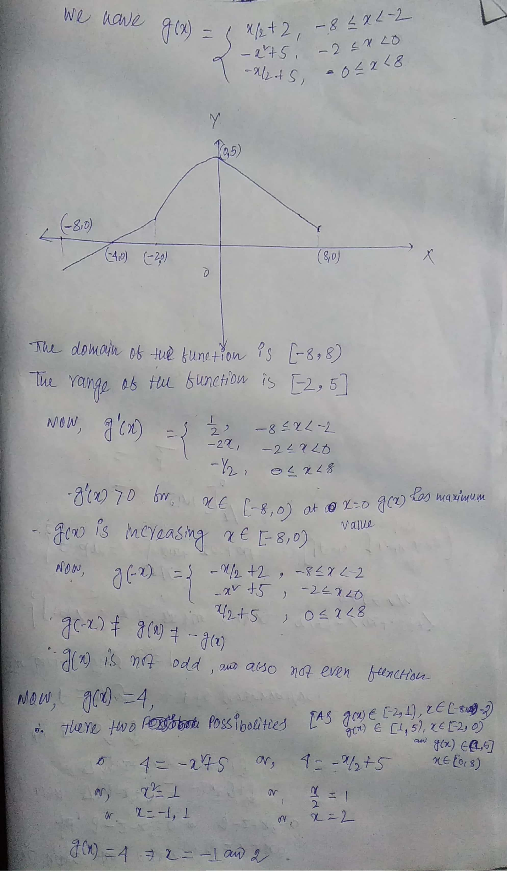Question 4 